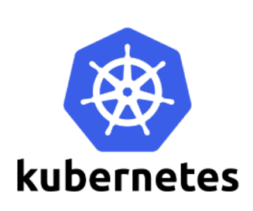

**Kubernetes Dashboard**

# Dashboard is a web-based Kubernetes user interface. You can use Dashboard to deploy containerized applications to a Kubernetes cluster, troubleshoot your containerized application, and manage the cluster itself along with its attendant resourcesWeb UI (Dashboard)

You can use Dashboard to get an overview of applications running on your cluster, as well as for creating or modifying individual Kubernetes resources (such as Deployments, Jobs, DaemonSets, etc). For example, you can scale a Deployment, initiate a rolling update, restart a pod or deploy new applications using a deploy wizard.

Dashboard also provides information on the state of Kubernetes resources in your cluster, and on any errors that may have occurred.

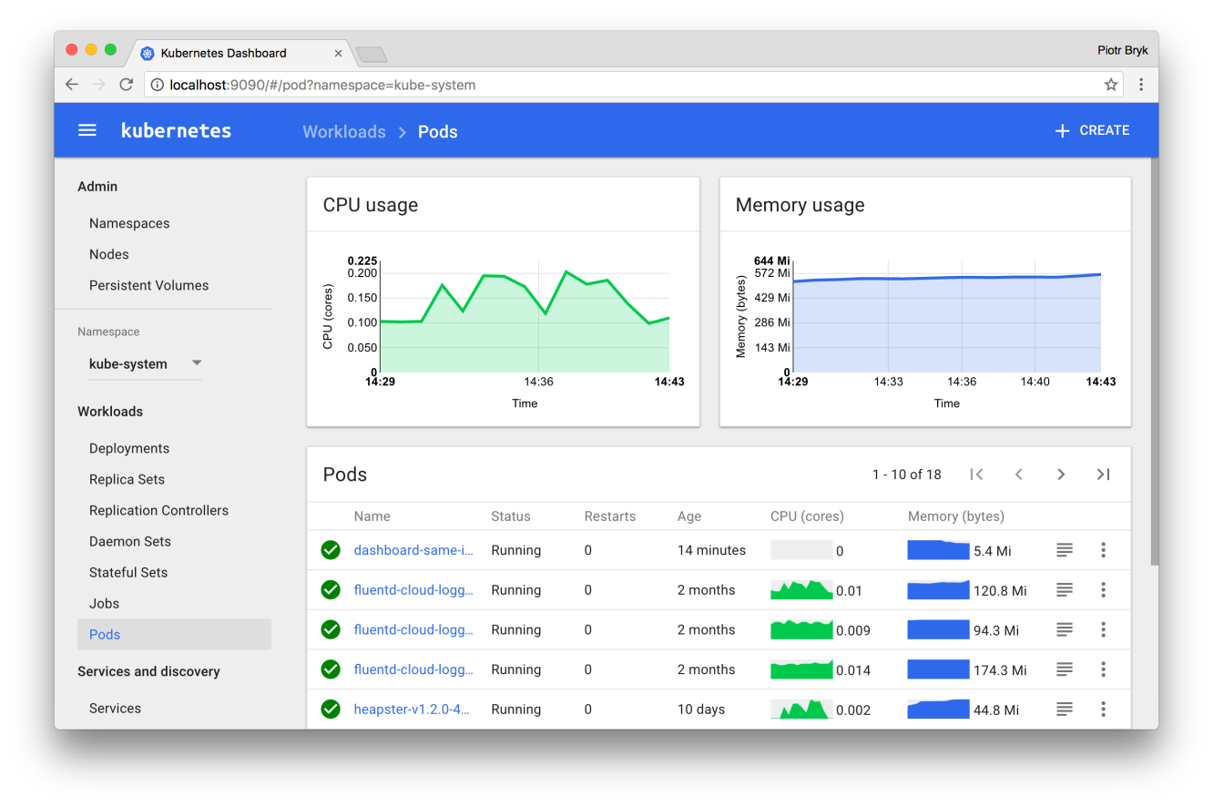

* Deploying the Dashboard UI
* Accessing the Dashboard UI
* Welcome view
* Deploying containerized applications
* Using Dashboard

## Deploying the Dashboard UI

The Dashboard UI is not deployed by default. To deploy it, run the following command:

kubectl create -f https://raw.githubusercontent.com/kubernetes/dashboard/master/src/deploy/recommended/kubernetes-dashboard.yaml

## Accessing the Dashboard UI

There are multiple ways you can access the Dashboard UI; either by using the kubectl command-line interface, or by accessing the Kubernetes master apiserver using your web browser.

### Command line proxy

You can access Dashboard using the kubectl command-line tool by running the following command:

kubectl proxy

Kubectl will handle authentication with apiserver and make Dashboard available at <http://localhost:8001/api/v1/namespaces/kube-system/services/https:kubernetes-dashboard:/proxy/>.

The UI can only be accessed from the machine where the command is executed. See kubectl proxy --help for more options.

### Master server

You may access the UI directly via the Kubernetes master apiserver. Open a browser and navigate to https://<master-ip>:<apiserver-port>/api/v1/namespaces/kube-system/services/https:kubernetes-dashboard:/proxy/, where <master-ip> is IP address or domain name of the Kubernetes master.

Steps to Setup the dashboard

Step-1: Deploy the dashboard Application

kubectl create -f https://raw.githubusercontent.com/kubernetes/dashboard/master/src/deploy/recommended/kubernetes-dashboard.yaml

Step-2: create cluster admin service account using yaml file

kubectl create -f https://raw.githubusercontent.com/devopstraining4/kubenetes_dt/master/dashboard2/dashboard-admin.yaml

step-3 run proxy for master Ip

nohup kubectl proxy --address="192.168.187.210" -p 443 --accept-hosts='^*$' &

ps -a

Step-4 access the console

http:// 192.168.198.134:443/api/v1/namespaces/kube-system/services/https:kubernetes-dashboard:/proxy/

http://192.168.198.134:443/api/v1/namespaces/kube-system/services/https:kubernetes-dashboard:/proxy/#!/login